**Experiment No. 6**

**Title: Conversion of one type of flip flop to other type of**

**flip-flop (J-K, D, and T flip-flop )**

**Batch: B1 Roll No.: 1914078 Experiment No.: 6**

**Aim:** To study flip flops (J-K, D, and T flip flop) using IC 7476 and Conversion of one type of flip flop to other type of flip-flop (J-K, D, and T flip-flop) **_______________________________________________________________ ___ _**

**Resources needed:** Simulation Platform

**Theory:**

**Theory:** "Flip-flop" is the common name given to two-state devices which offer basic memory for sequential logic operations. Flip-flops are heavily used for digital data storage and transfer and are commonly used in banks called "registers" for the storage of binary numerical data.

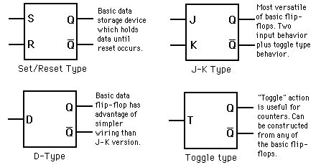

Fig: Types of Flip-flops

**Set-Reset FlipFlop:**

The set/reset type flip-flop is triggered to a high state at Q by the "set" signal and holds that value until reset to low by a signal at the Reset input. This can be implemented as a NAND gate latch or a NOR gate latch and as a clocked version.

One disadvantage of the S/R flip-flop is that the input S=R=1 gives ambiguous results and must be avoided. The J-K flip-flop gets around that problem.

**JK FlipFlop:**

JK-flip flop has two inputs, traditionally labeled J and K. IC 7476 is a dual JK master slave flip flop with preset and clear inputs. If J and K are different then the output Q takes the value of J at the next clock edge. If J and K are both low then no change occurs. If J and K are both high at the clock edge then the output will toggle from one state to the other. It can perform the functions of the set/reset flip-flop and has the advantage that there are no ambiguous states.

**D FlipFlop:**

D flip-flop tracks the input, making transitions with match those of the input D. The D stands for "data"; this flip-flop stores the value that is on the data line. It can be thought of as a basic memory cell. D flip-flop can be made from J-K flip-flop by connecting both inputs through a not gate as shown in fig.

**T FlipFlop:**

T or "toggle" flip-flop changes its output on each clock edge, giving an output which is half the frequency of the signal to the T input. It is useful for constructing binary counters, frequency dividers, and general binary addition devices. It can be made from a J-K flip-flop by tying both of its inputs high.

Table: Characteristic table and Excitation Table of flipflops

|  |  |  |  |  |  |  |  |  |
| --- | --- | --- | --- | --- | --- | --- | --- | --- |
| **FlipFlop name** | **Characteristic Table** | | | **Characteristic Equation** | **Excitation Table** | | | |
| **SR** | **S** | **R** | **Qnext** |  | **Q** | **Qnext** | **S** | **R** |
| **0** | **0** | **Q** | **Qnext=**  **S+R’Q**  **Where SR=0** | **0** | **0** | **0** | **X** |
| **0** | **1** | **0** | **0** | **1** | **1** | **0** |
| **1** | **0** | **1** | **1** | **0** | **0** | **1** |
| **1** | **1** | **?** | **1** | **1** | **X** | **0** |
|  | | | | | | | | |
| **JK** | **J** | **K** | **Qnext** |  | **Q** | **Qnext** | **J** | **K** |
| **0** | **0** | **Q** | **Qnext=**  **JQ’+K’Q** | **0** | **0** | **0** | **X** |
| **0** | **1** | **0** | **0** | **1** | **1** | **X** |
| **1** | **0** | **1** | **1** | **0** | **X** | **1** |
| **1** | **1** | **Q’** | **1** | **1** | **X** | **0** |
|  | | | | | | | | |
| **D** | **D** | | **Qnext** |  | **Q** | **Qnext** | **D** | |
| **0** | | **0** | **Qnext=D** | **0** | **0** | **0** | |
| **1** | | **1** | **0** | **1** | **1** | |
|  | |  | **1** | **0** | **0** | |
|  | |  | **1** | **1** | **1** | |
|  | | | | | | | | |
| **T** | **T** | | **Qnext** |  | **Q** | **Qnext** | **T** | |
| **0** | | **Q** | **Qnext=**  **TQ’+T’Q** | **0** | **0** | **0** | |
| **1** | | **Q’** | **0** | **1** | **1** | |
|  | |  | **1** | **0** | **1** | |
|  | |  | **1** | **1** | **0** | |

**Procedure**:

1. Draw the pinout diagram of IC 7476
2. Convert JK flipflop to D and T flip. (Show the procedure on separate sheets.)
3. Connect the J&K flipflop as D and T flip flop and verify the respective Characteristic Tables.

**___________________________________________________________________________**

**Observations and Results:**

1. Complete the Characteristic and Excitation Tables of SR, JK, T AND D flipflps.
2. Show the conversion of JK flipflop to D and T flipflop.
3. Observe the output for all the possible combinations of input.

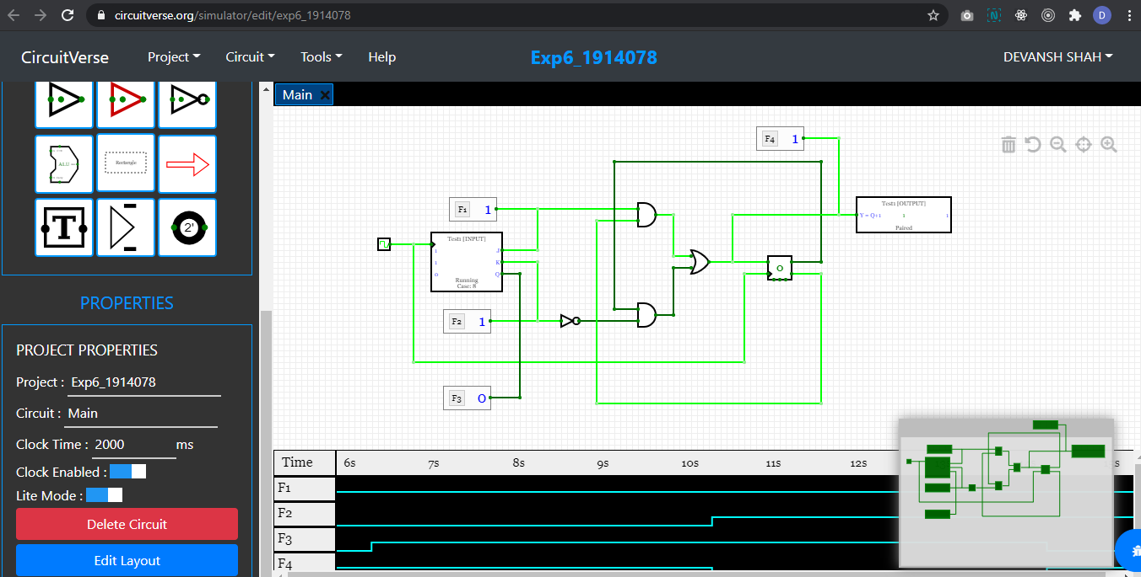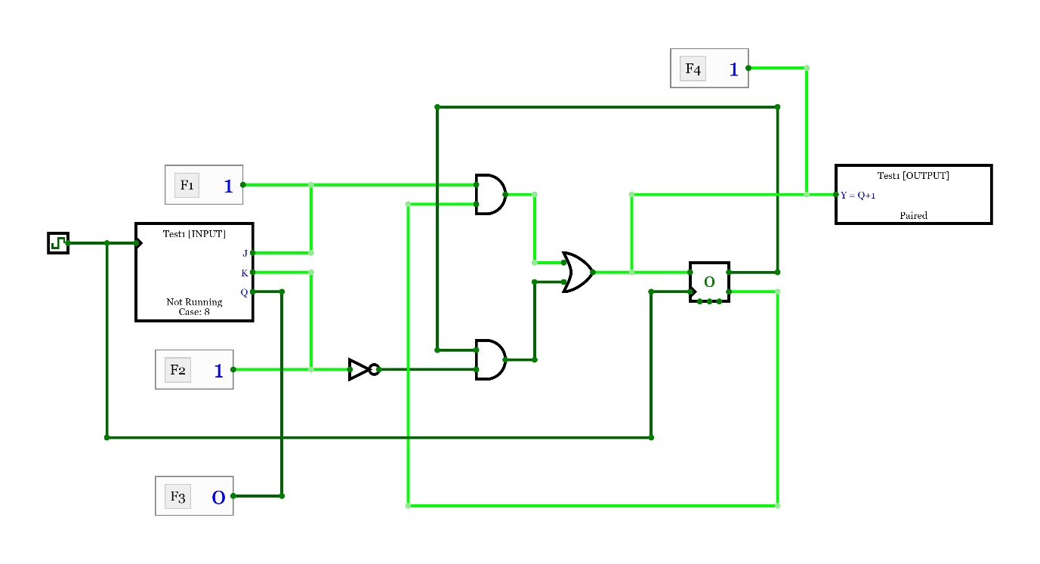

Test bench:

{"n":8,"inputs":[{"bitWidth":"1","label":"J","values":["0","0","0","0","1","1","1","1"]},{"bitWidth":"1","label":"K","values":["0","0","1","1","0","0","1","1"]},{"bitWidth":"1","label":"Q","values":["0","0","0","0","0","1","1","0"]}],"outputs":[{"bitWidth":"1","label":"Y = Q+1","values":["0","0","0","0","1","1","0","1"]}]}

**Outcomes:** Design the combinational and sequential circuits using basic building blocks and MSI devices.

**___________________________________________________________________________**

**Conclusion:** We studied flip flops (J-K, D, and T flip flop) using IC 7476 and Conversion of one type of flip flop to other type of flip-flop.

**Grade: AA / AB / BB / BC / CC / CD /DD**

**Signature of faculty in-charge with date**

**___________________________________________________________________________**

**References:**

**Books/ Journals/ Websites:**

1. R. P. Jain, “Modern Digital Electronics”, Tata McGraw Hill.
2. <http://hyperphysics.phy-astr.gsu.edu/hbase/electronic/flipflop.html>